

RESOURCES

VERSION CONTROL SYSTEM WITH GIT

Create a distributed Repository and add members in project team

* Login to your GitHub account and you will land on the homepage as shown below. Click on Repositories option in the menu bar.

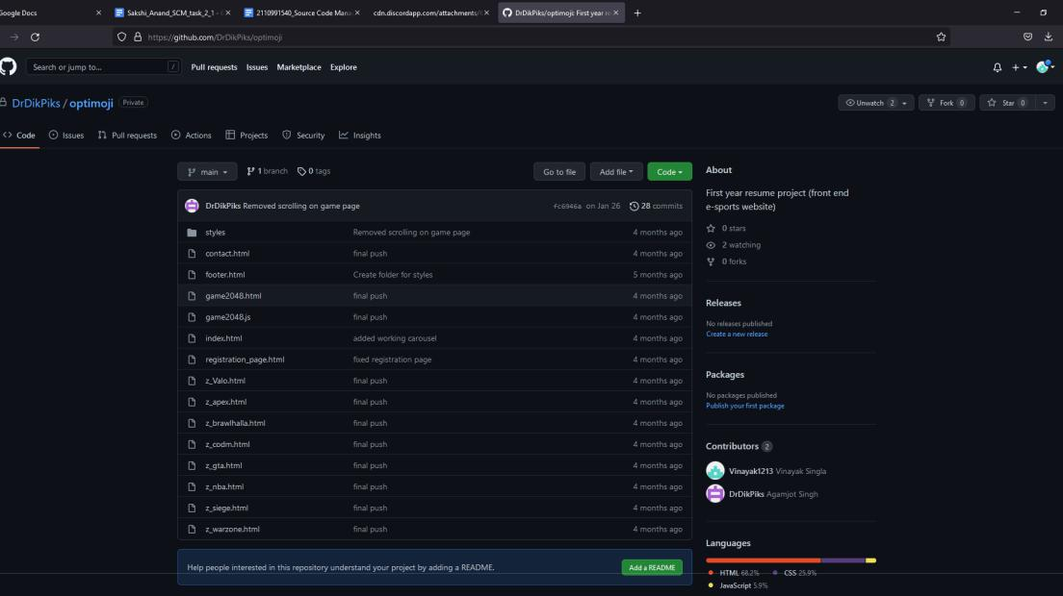

• Click on the ‘New’ button in the top right corner.

CS181 Page 4

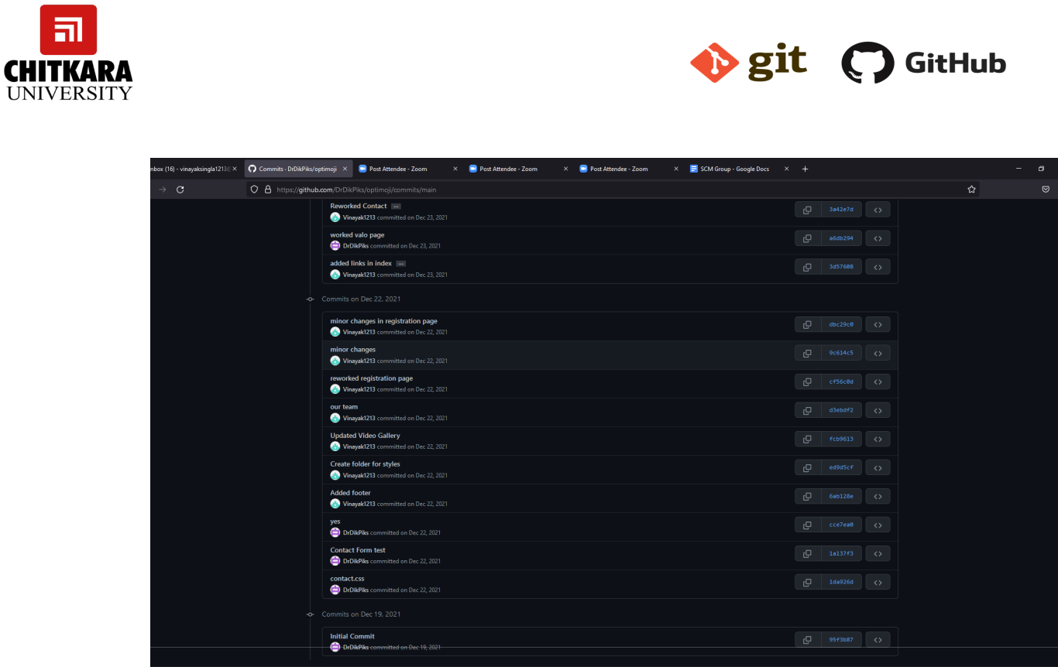

* Enter the Repository name and add the description of the repository.
* Select if you want the repository to be public or private.
* Click to the create repository.

CS181 Page 5



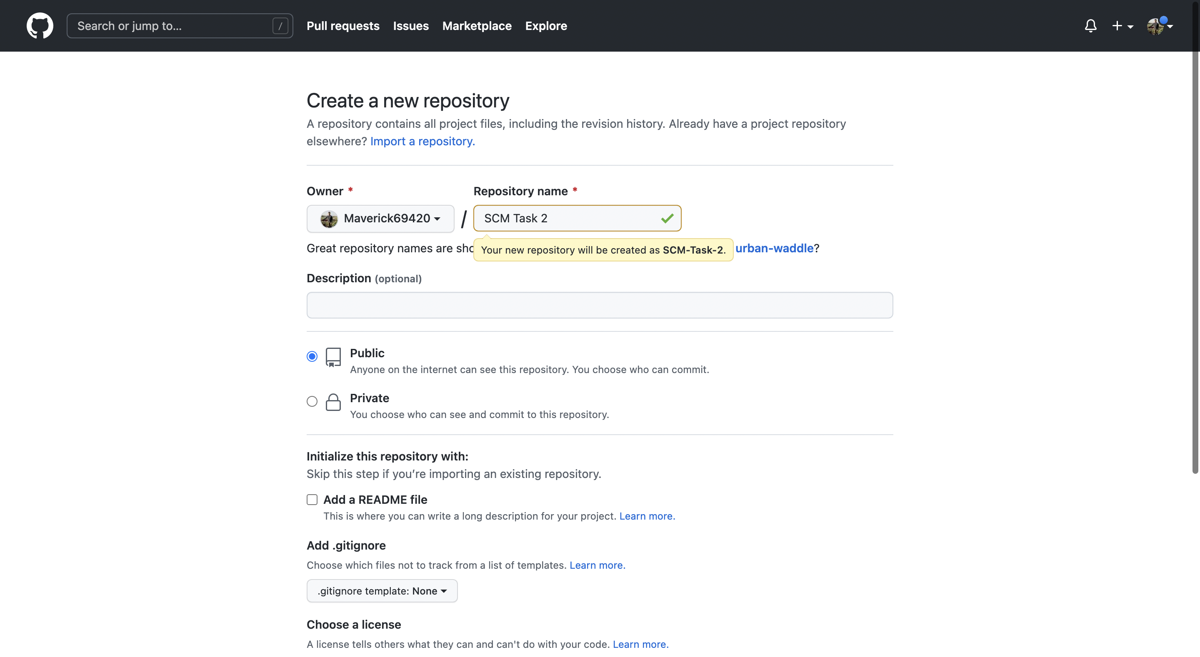

* If you want to import code from an existing repository select the import code Option.

CS181 Page 6

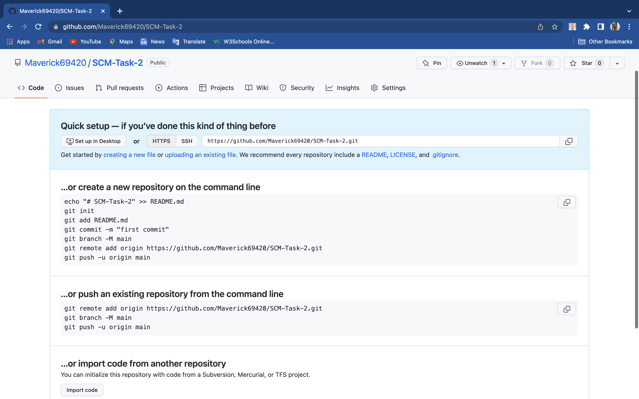

* Now, you have created your repository successfully.
* To add members to your repository, open your repository and select the settings option in the navigation bar.
* Click on Collaborators option under the access tab.

CS181 Page 7





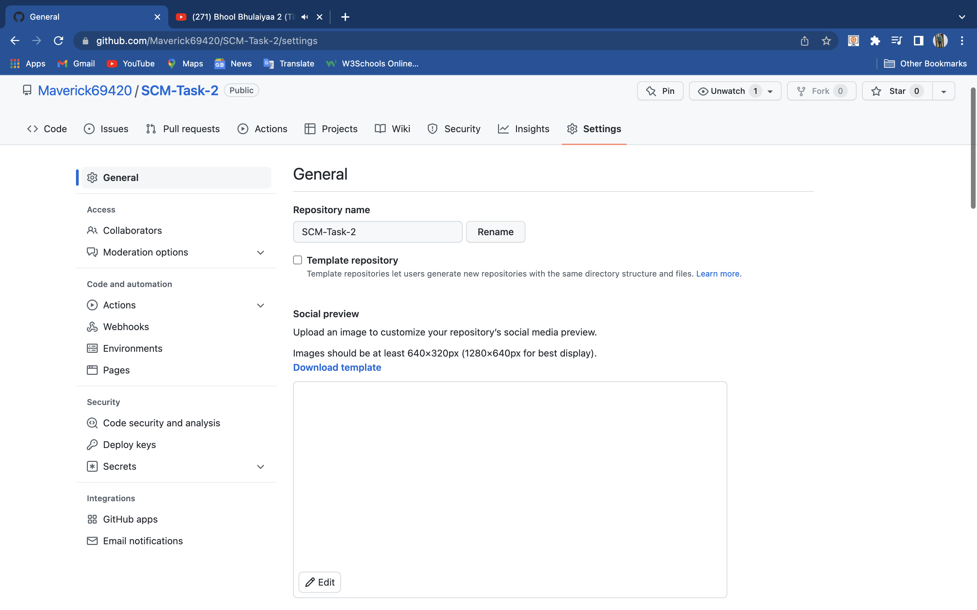

* After clicking on collaborators GitHub asks you to enter your password to confirm the access to the repository.

CS181 Page 8



* After clicking on collaborators GitHub asks you to enter your password to confirm the access to the repository.

Fk

* After entering the password, you can manage access and add/remove team member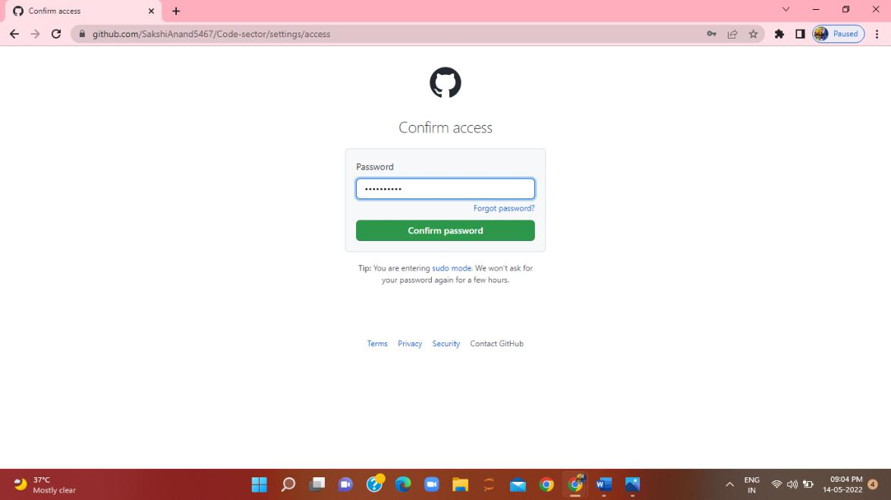s to your project.
* To add members, click on the add people option and search the id of your respective team member.

CS181 Page 9



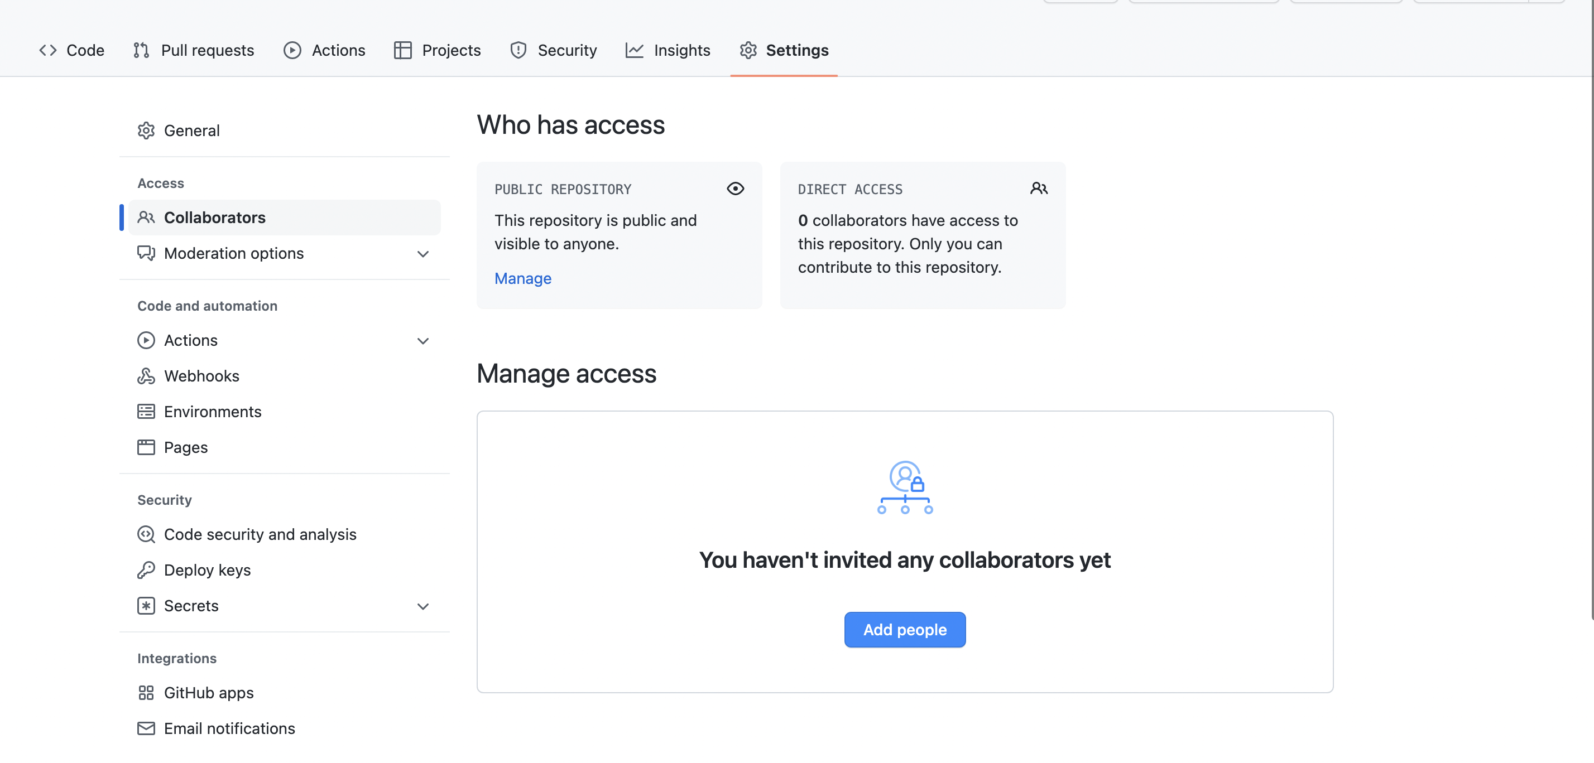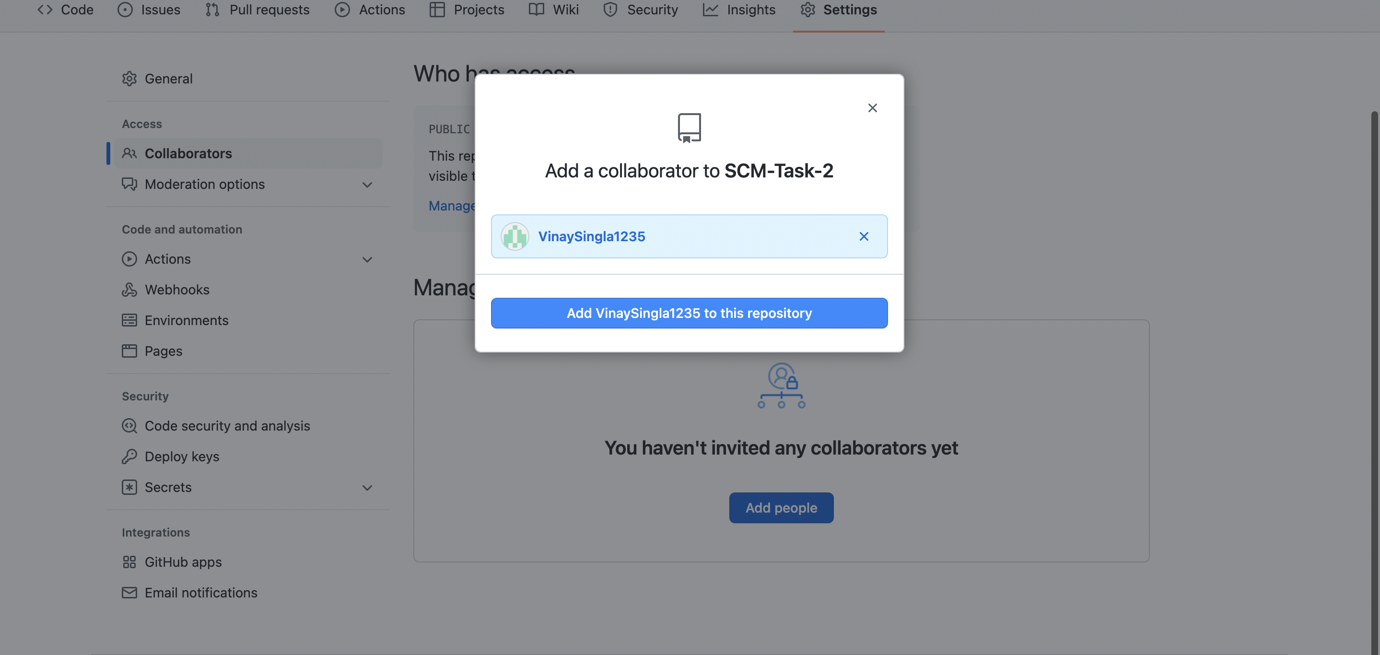

Now, click on green box to add member in your repository.

* To remove any member, click on remove option is available .

CS181 Page 10



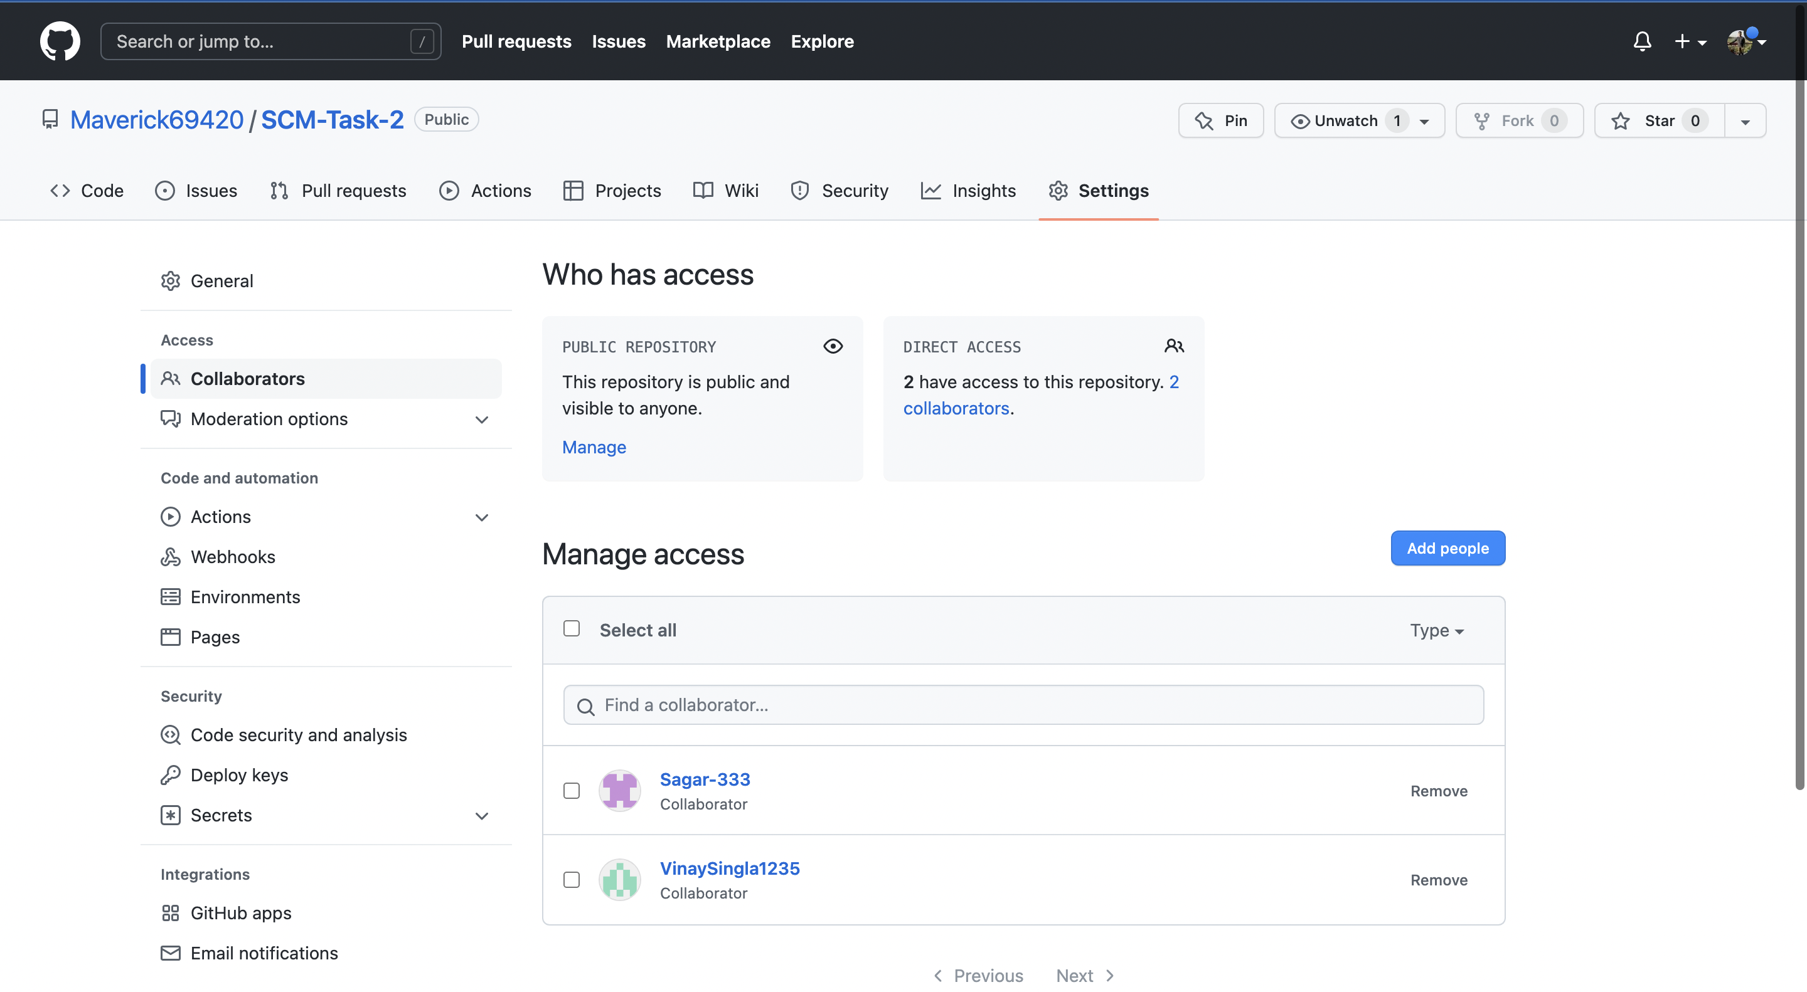

* To accept the invitation from your team member, open your email registered with GitHub.
* You will receive an invitation mail from the repository owner. Open the email and click on accept invitation.
* You will be redirected to GitHub where you can either select to accept or decline the invitation.



CS181 Page 11



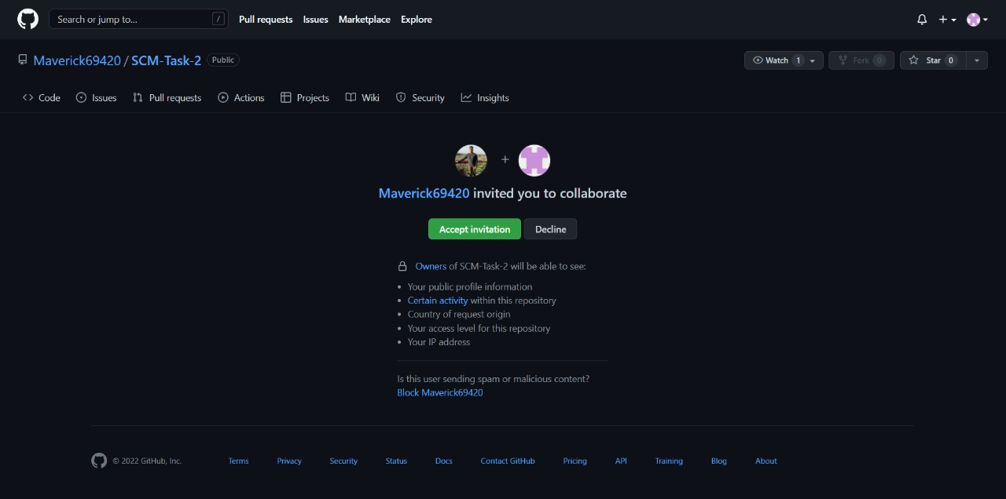

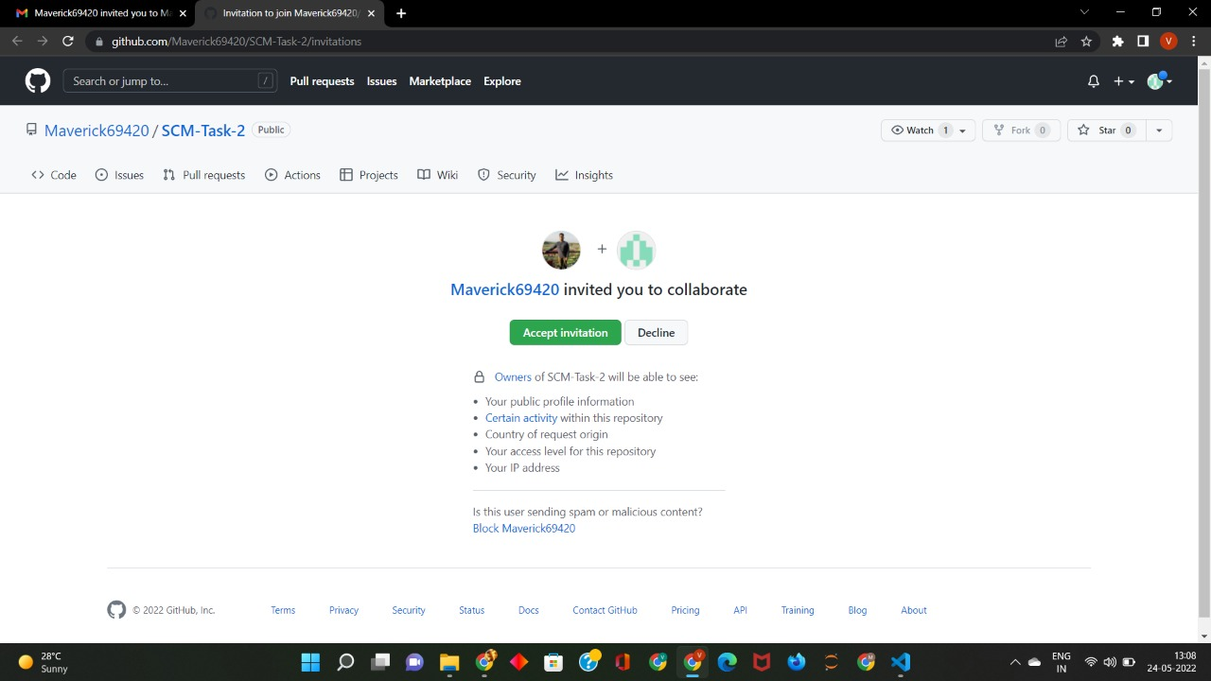

* Now all members are ready to contribute to the project.

CS181 Page 12



**RESOURCES USED**

CS181 Page 14

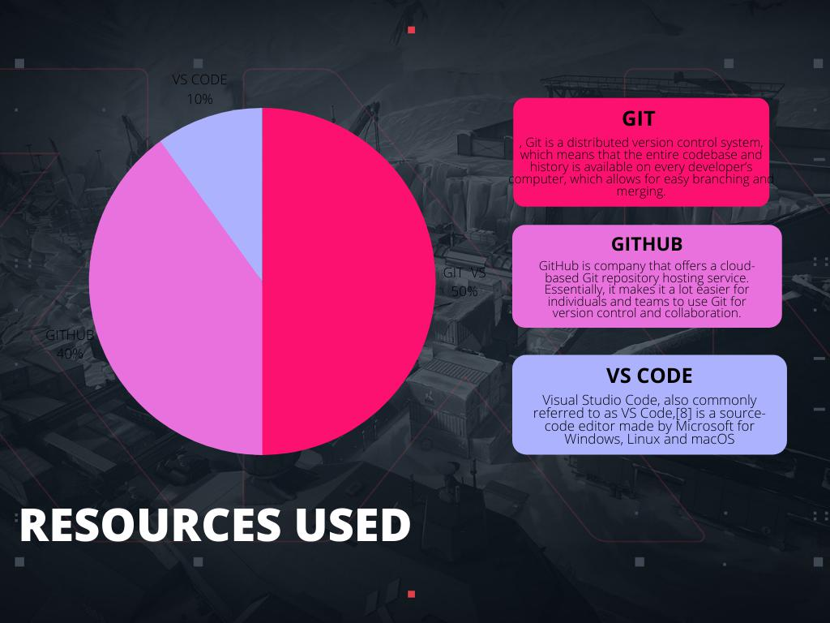

**PROBLEM STATEMENT:**

**1. Performance**

Git performs very strongly and reliably when compared to other version control systems. New code changes can be easily committed, version branches can be effortlessly compared and merged, and code can also be optimised to perform better. Algorithms used in developing Git take the full advantage of the deep knowledge stored within, with regards to the attributes used to create real source code file trees, how files are modified over time and what kind of file access patterns are used to recall code files as and when needed by developers. Git primarily focuses upon the file content itself rather than file names while determining the storage and file version history. Object formats of Git repository files use several combinations of delta encoding and compression techniques to store metadata objects and directory contents.

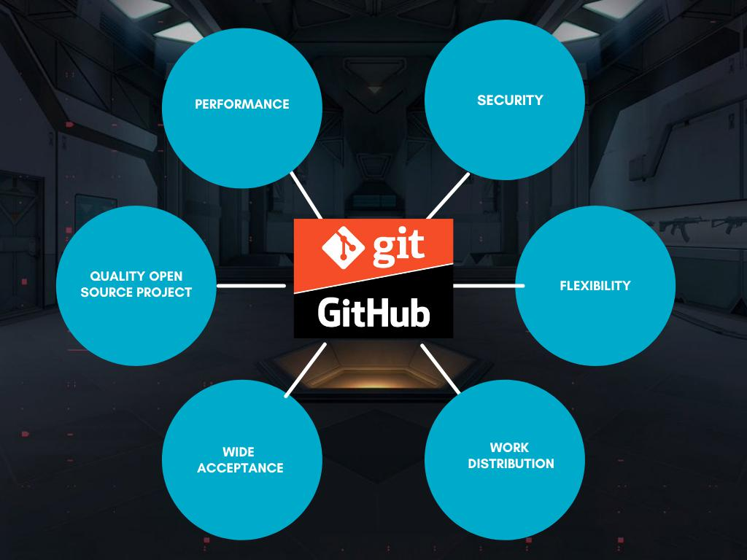

**PROBLEM STATEMENT**

CS181 Page 14





**2. Security**

Git is designed specially to maintain the integrity of source code. File contents as well as the relationship between file and directories, tags, commits, versions etc. are secured cryptographically using an algorithm called SHA1 which protects the code and change history against accidental as well as malicious damage. You can be sure to have an authentic content history for your source code with Git.

**3. Flexibility**

A key design objective of Git is the kind of flexibility it offers to support several kinds of nonlinear development workflows and its efficiency in handling both small scale and large scale projects as well as protocols. It is uniquely designed to support tagging and branching operations and store each and every activity carried out by the user as an integral part of “change” history. Not all VCSs support this feature.

**4. Wide acceptance**

Git offers the type of performance, functionality, security, and flexibility that most developers and teams need to develop their projects. When compared to other VCS Git is the most widely accepted system owing to its universally accepted usability and performance standards.

**5. Quality open source project**

Git is a widely supported open source project with over ten years of operational history. People maintaining the project are very well matured and possess a long-term vision to meet the long-term needs of users by releasing staged upgrades at regular intervals of time to improve functionality as well as usability. Quality of open source software made available on Git is heavily scrutinised a countless number of times and businesses today depend heavily on Git code quality.

CS181 Page 17

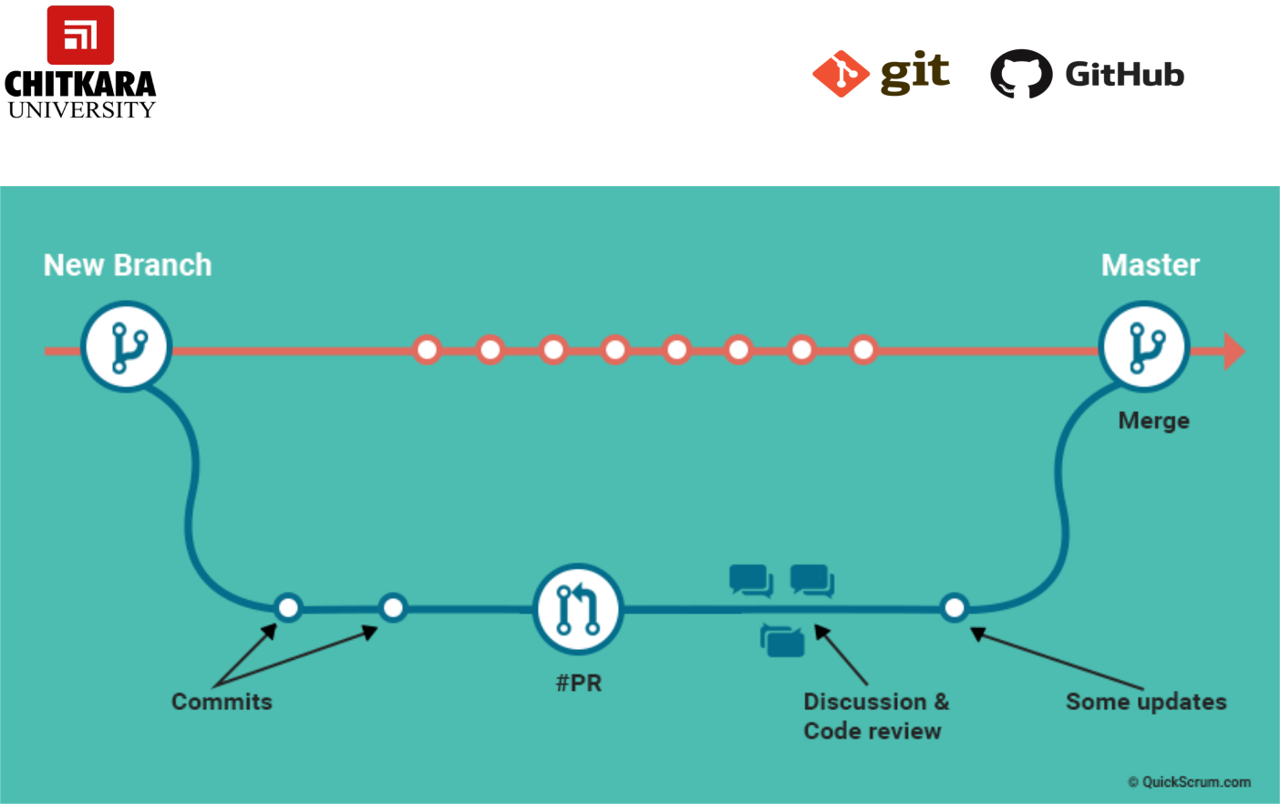

**Pull Requests:**

A developer calls a pull request to ask another developer to merge one of his/her branches into the other’s repository. Besides making it a lot easier for project leaders to monitor and track code changes, “pulling” also facilitates other developers to discuss their work before integrating the code with the codebase. Moreover, if a developer can’t continue work owing to some hard technical problem, he/she can initiate a pull request to seek help from the rest of the team.

We are going to represent the Problem Statement through one of the examples which will help us to understand better how it can reduce the work time and in this particular example we are going to cover how we can pull a repository directly from GitHub instead of sending the file to a number of the users individually. How one can pull directly from Github by following some basic steps

Open and Close a Pull Request

* To open a pull request we first have to make a new branch, by using git branch.
* After making a new branch we add a file to the branch or make change in the existing file.

CS181 Page 17

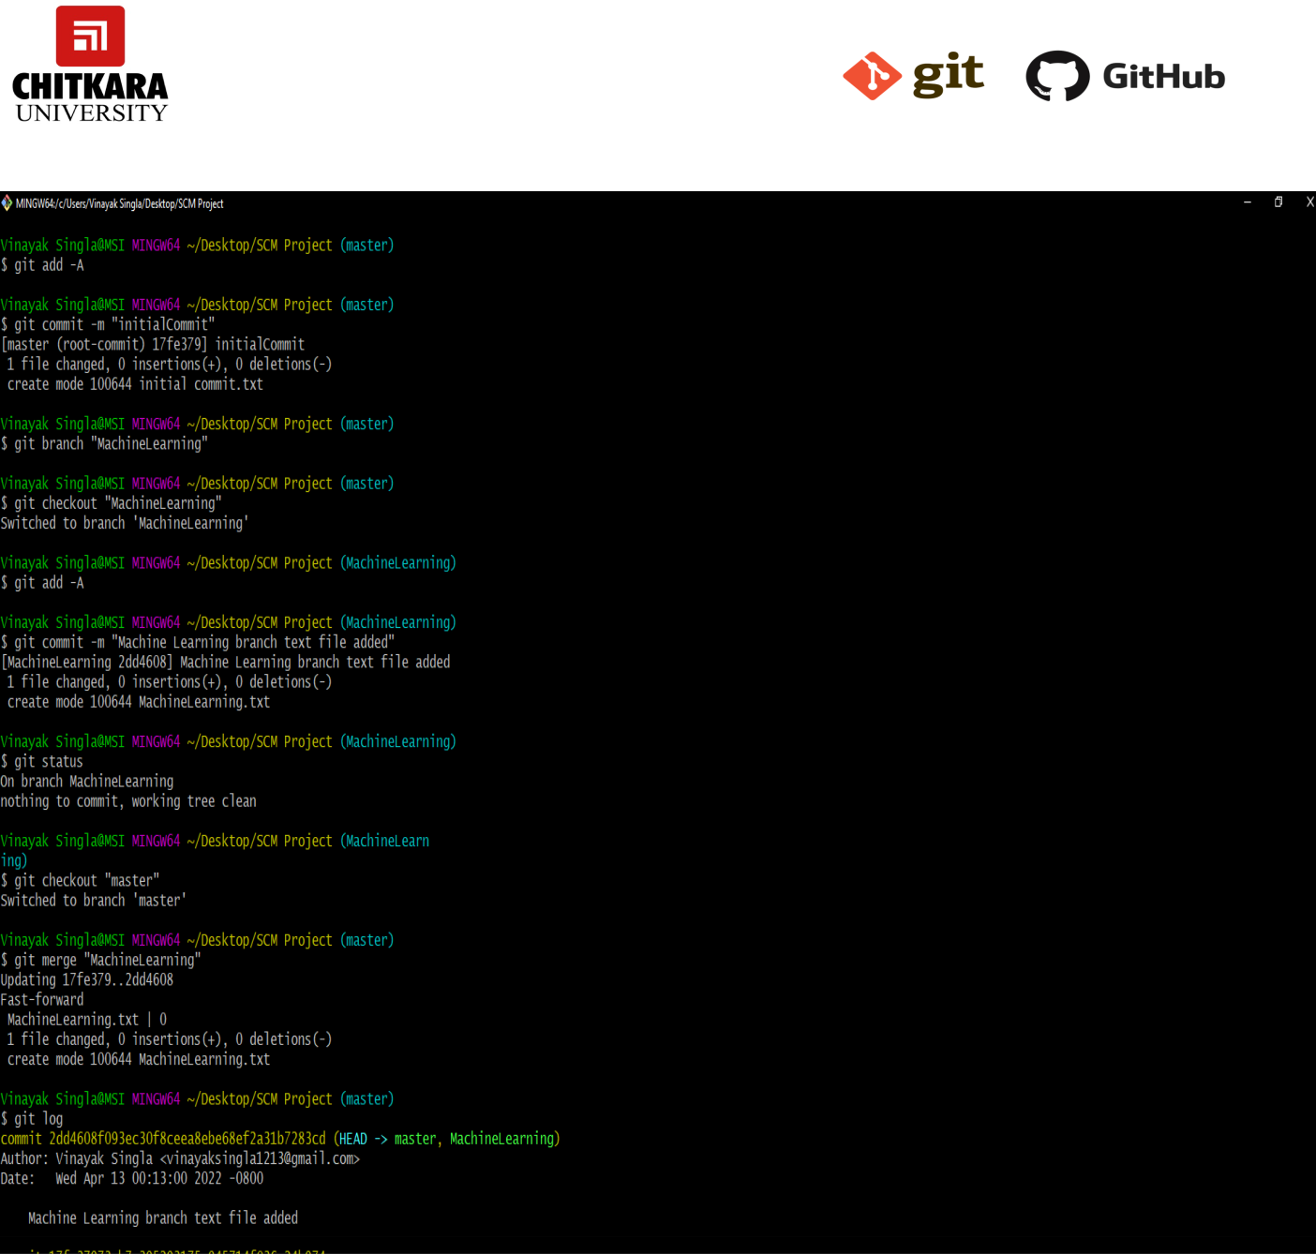

CS181 Page 18



* Use git push origin to push the new branch to the main repository.
* After pushing new branch GitHub will either automatically ask you to create a pull request or you can create your own pull request by selecting the option compare & pull request.

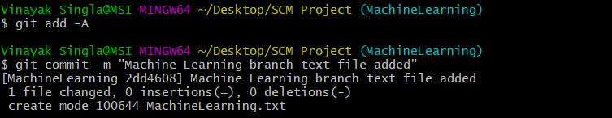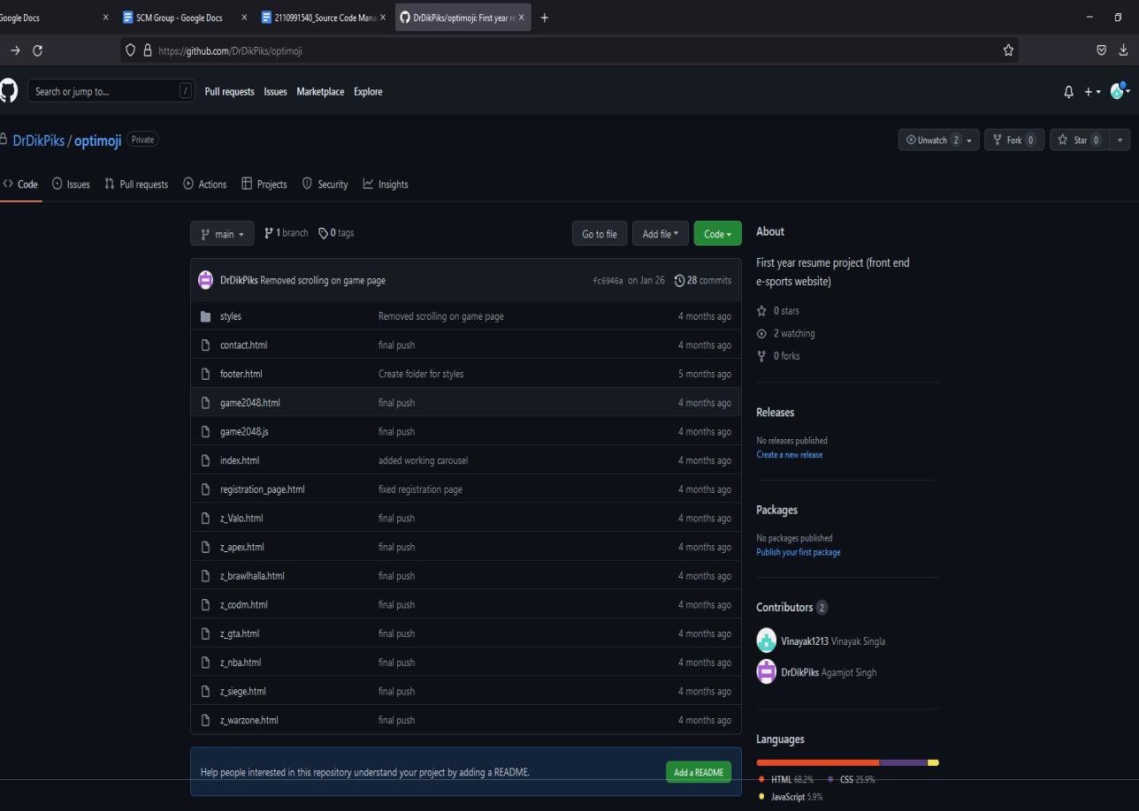

CS181 Page 19

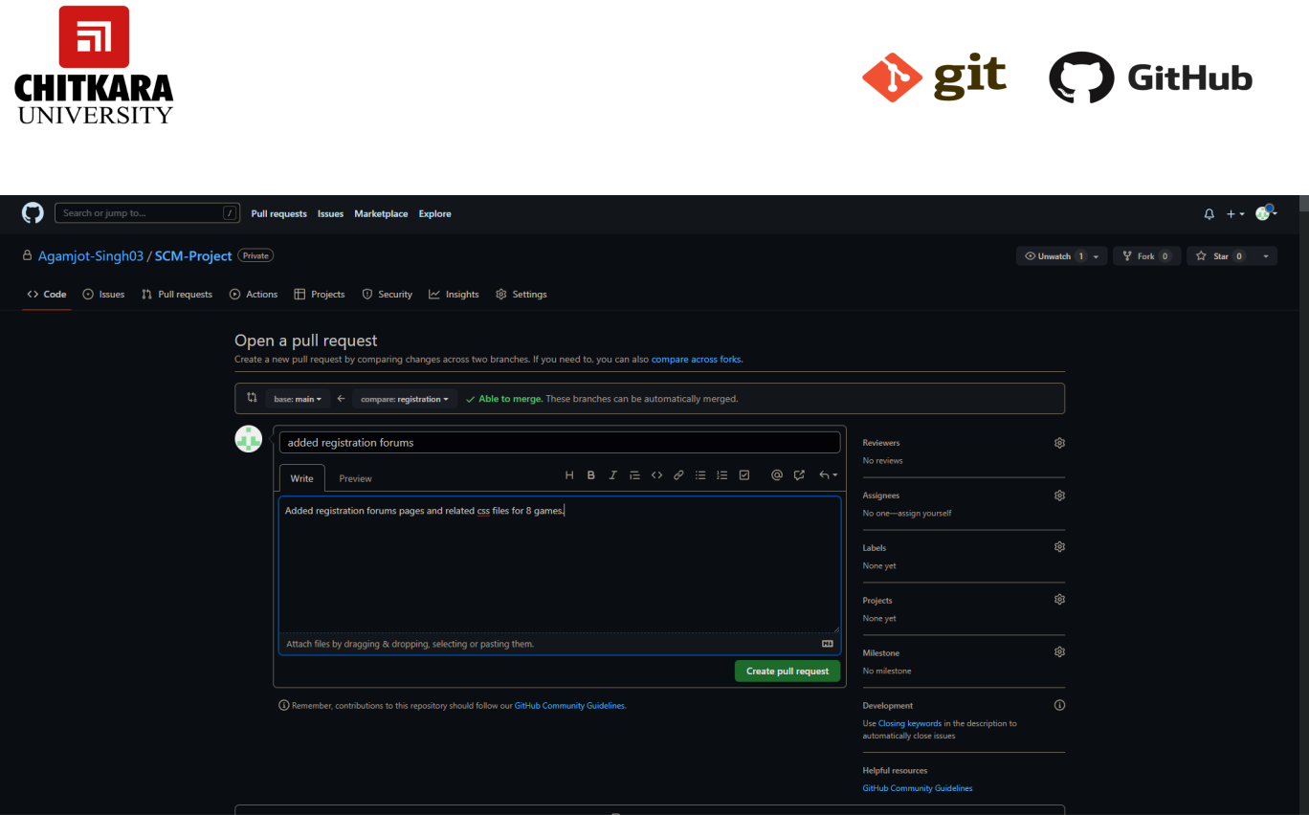

* To create your own pull request, click on create pull request option.
* GitHub will detect any conficts and ask you to enter a description of your pull request.
* After opening a pull request all the team members will be sent the request if they want to merge or close the request.

CS181 Page 20

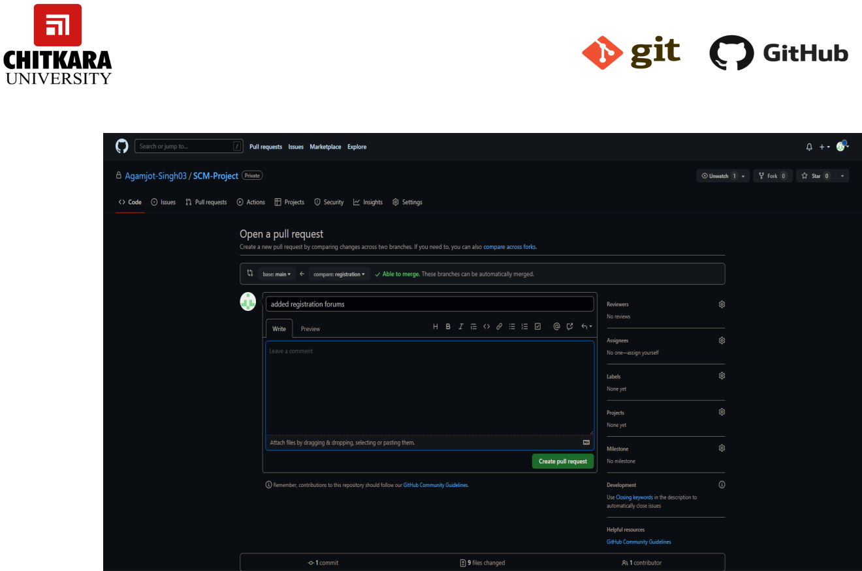

* If the team member chooses not to merge your pull request they will close the pull request.
* To close the pull request simply click on close pull request and add comment/ reason why you closed the pull request.
* You can see all the pull requests generated and how they were dealt with by clicking on pull request option.

CS181 Page 21



1. **CONCEPTS, COMMANDS AND OBJECTIVE**

Aim: Create a pull request on a team member’s repo and close pull requests generated by team members on own Repo as a maintainer

To create a pull request on a team member’s repository and close requests by any other team members as a maintainer follow the procedure given below: -

* Do the required changes in the repository, add and commit these changes in the local repository in a new branch.
* Push the modifed branch using git push origin branchname.
* Open a pull request by following the procedure from the above experiment.
* The pull request will be created and will be visible to all the team members.
* Ask your team member to login to his/her Github account.
* They will notice a new notifcation in the pull request menu.
* Click on it. The pull request generated by you will be visible to them.



CS181 Page 22

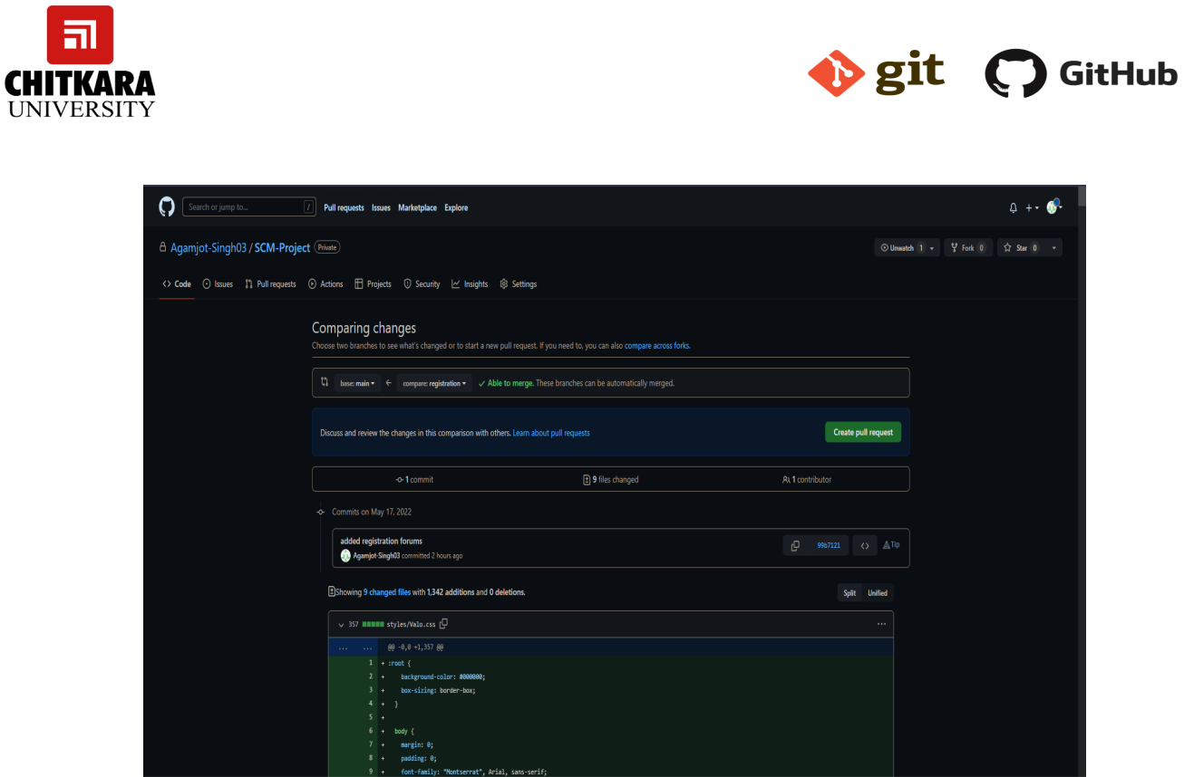

* Click on the pull request. Two options will be available, either to close the pull request or merge the request with the main branch.
* By selecting the merge pull request, the main branch will get updated for all the team members.
* By selecting close the pull request the pull request is not accepted and not merged with the main branch.

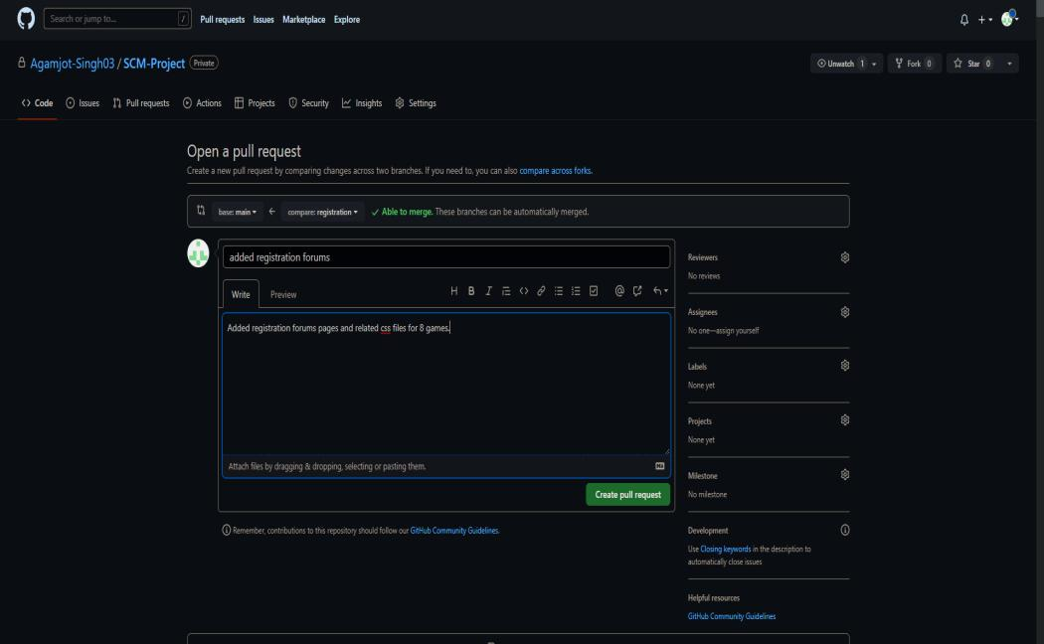

CS181 Page 23



* The process is similar to closing and merging the pull request by you. It simply includes an external party to execute.
* The result of merging the pull request is shown below.

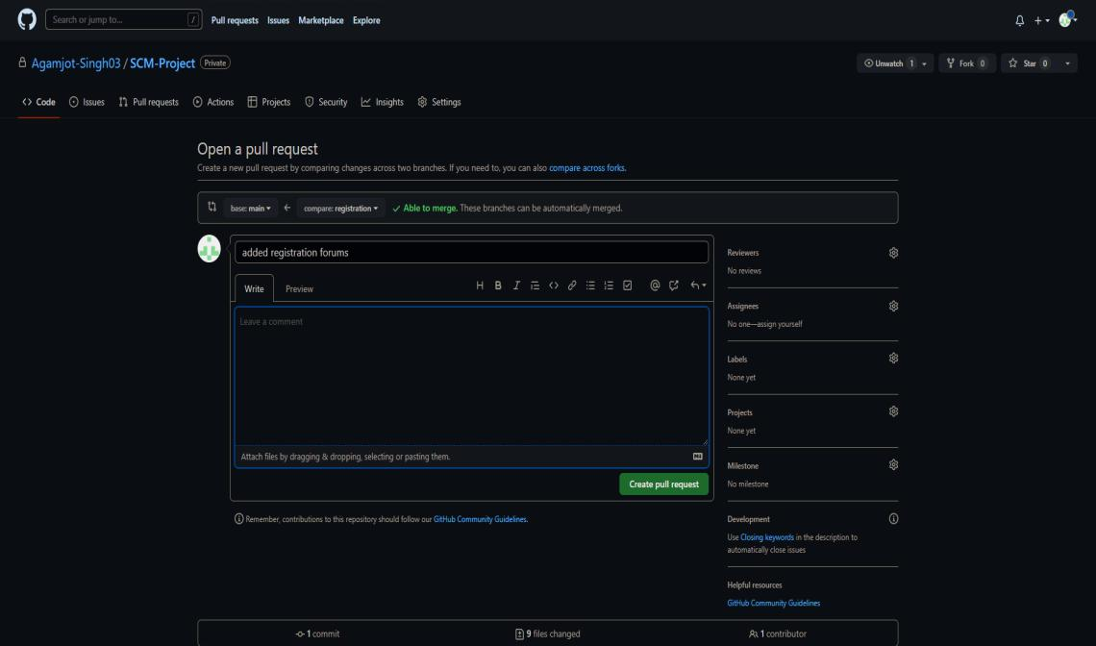

CS181 Page 24



**FLOWCHART, WORKFLOW AND DISCUSSIONS IN GIT**

**FLOWCHART AND WORKFLOW**

**What is a successful Git workflow?**

When evaluating a workflow for your team, it's most important that you consider your team’s culture. You want the workflow to enhance the effectiveness of your team and not be a burden that limits productivity. Some things to consider when evaluating a Git workflow are:

* Does this workflow scale with team size?
* Is it easy to undo mistakes and errors with this workflow?
* Does this workflow impose any new unnecessary cognitive overhead to the team?

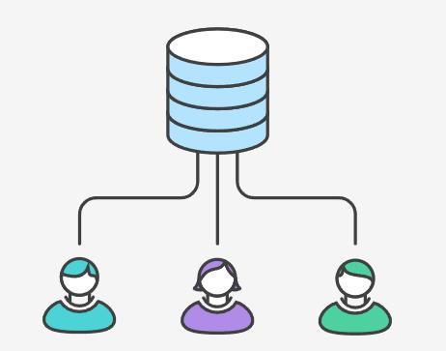

**Centralized Workflow**

The Centralized Workflow is a great Git workflow for teams transitioning from SVN. Like Subversion, the Centralized Workflow uses a central repository to serve as the single point-of-entry for all changes to the project. Instead of trunk, the default development branch is called main and all changes are committed into this branch. This workflow doesn’t require any other branches besides main.

CS181 Page 25



It gives every developer their own local copy of the entire project. This isolated environment lets each developer work independently of all other changes to a project - they can add commits to their local repository and completely forget about upstream developments until it's convenient for them.

**How it works**

Developers start by cloning the central repository. In their own local copies of the project, they edit files and commit changes these new commits are stored locally - they’re completely isolated from the central repository. This lets developers defer synchronizing upstream until they’re at a convenient break point.

To publish changes to the official project, developers "push" their local main branch to the central repository.

* **Initialize the central repository**

First, someone needs to create the central repository on a server.

Central repositories should always be bare repositories

Be sure to use a valid SSH username for user, the domain or IP address of your server for host, and the location where you'd like to store your repo

* **Hosted central repositories**

Central repositories are often created through 3rd party Git hosting services

The hosting service will then provide an address for the central repository to access from your local repository.

* **Clone the central repository**

Next, each developer creates a local copy of the entire project. This is accomplished via the git clone command:

* **Make changes and commit**

Once the repository is cloned locally, a developer can make changes using the standard Git commit process: edit, stage, and commit.

* **Push new commits to central repository**

Once the local repository has new changes committed. These change will need to be pushed to share with other developers on the project. This is accomplished via the git push origin command

CS181 Page 26

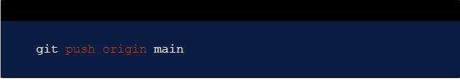

* **Managing conflicts**

The central repository represents the official project, so its commit history should be treated as sacred and immutable. If a developer’s local commits diverge from the central repository, Git will refuse to push their changes because this would overwrite official commits.

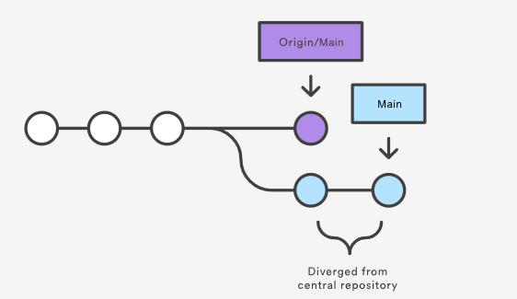

Before the developer can publish their feature, they need to fetch the updated central commits and rebase their changes on top of them. This is like saying, “I want to add my changes to what everyone else has already done.”

If local changes directly conflict with upstream commits, Git will pause the rebasing process and give you a chance to manually resolve the conflicts. The nice thing about Git is that it uses the same git status and git add commands for both generating commits and resolving merge conflicts. This makes it easy for new developers to manage their own merges. Plus, if they get themselves into trouble, Git makes it very easy to abort the entire rebase and try again

CS181 Page 27

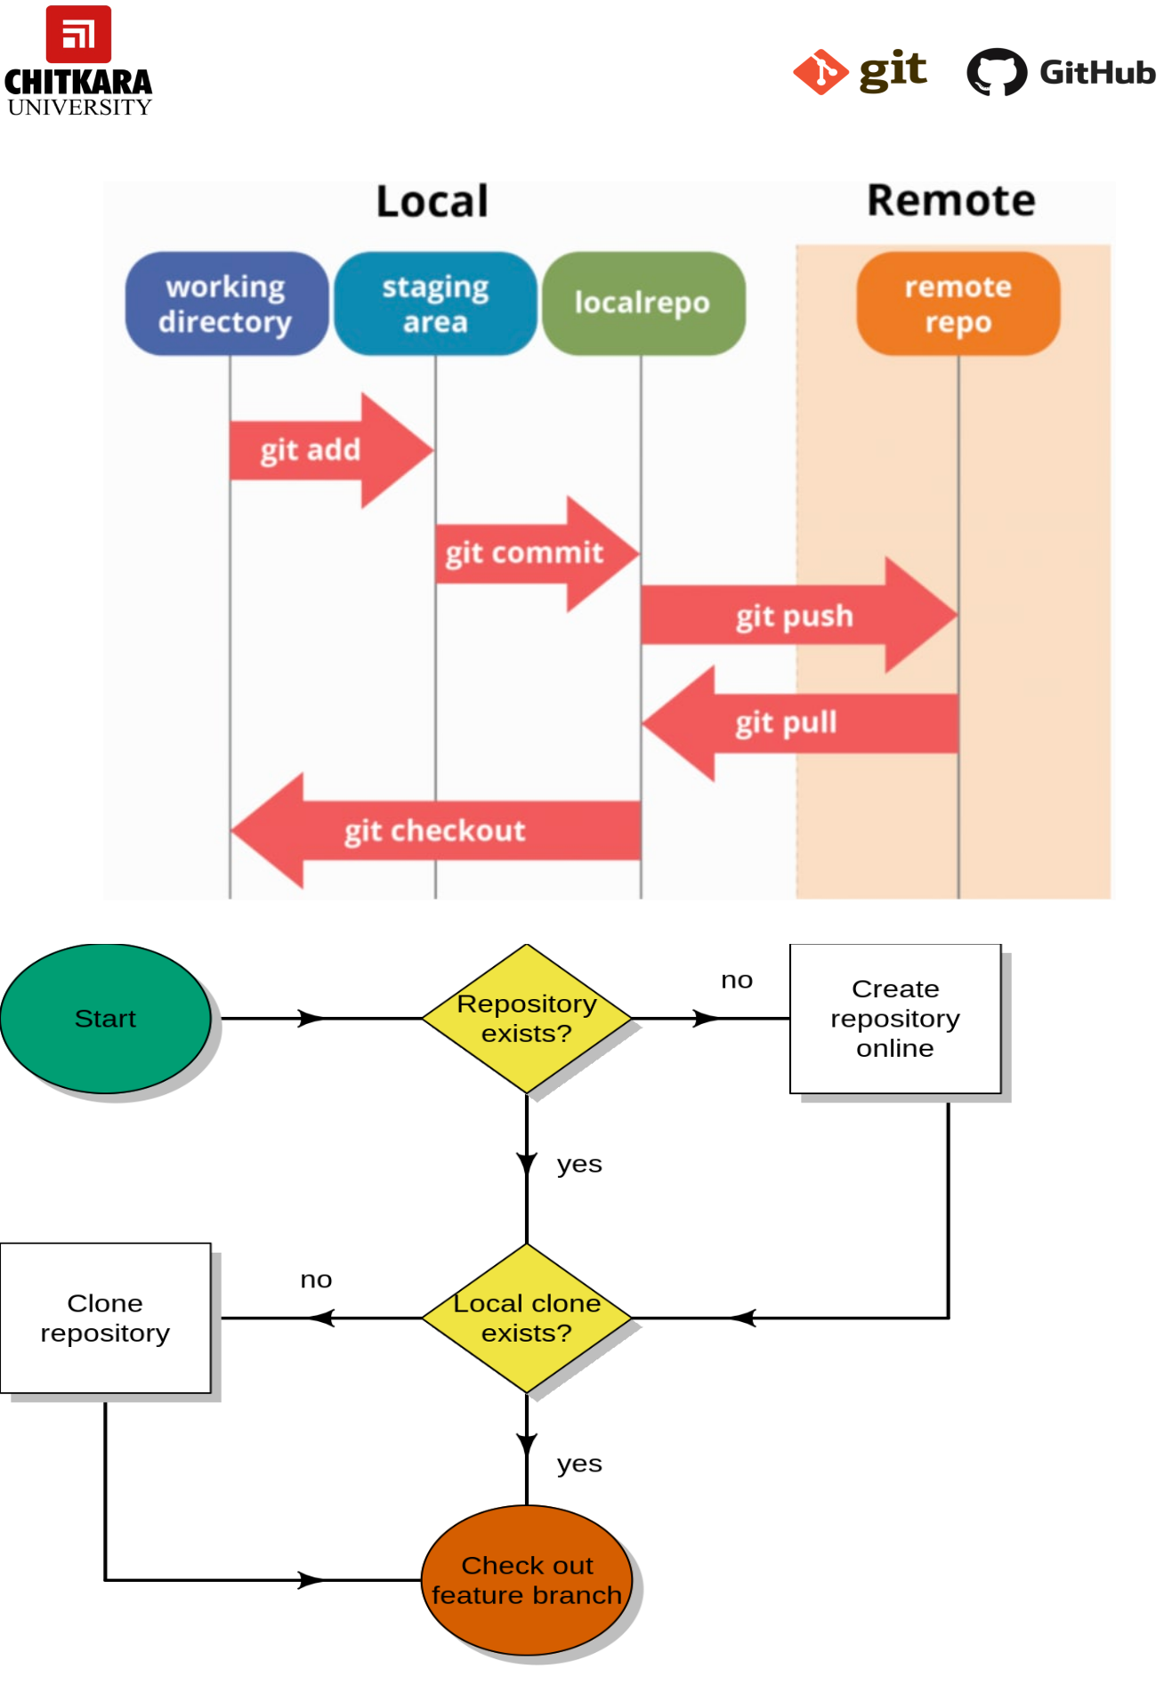

CS181 Page 28

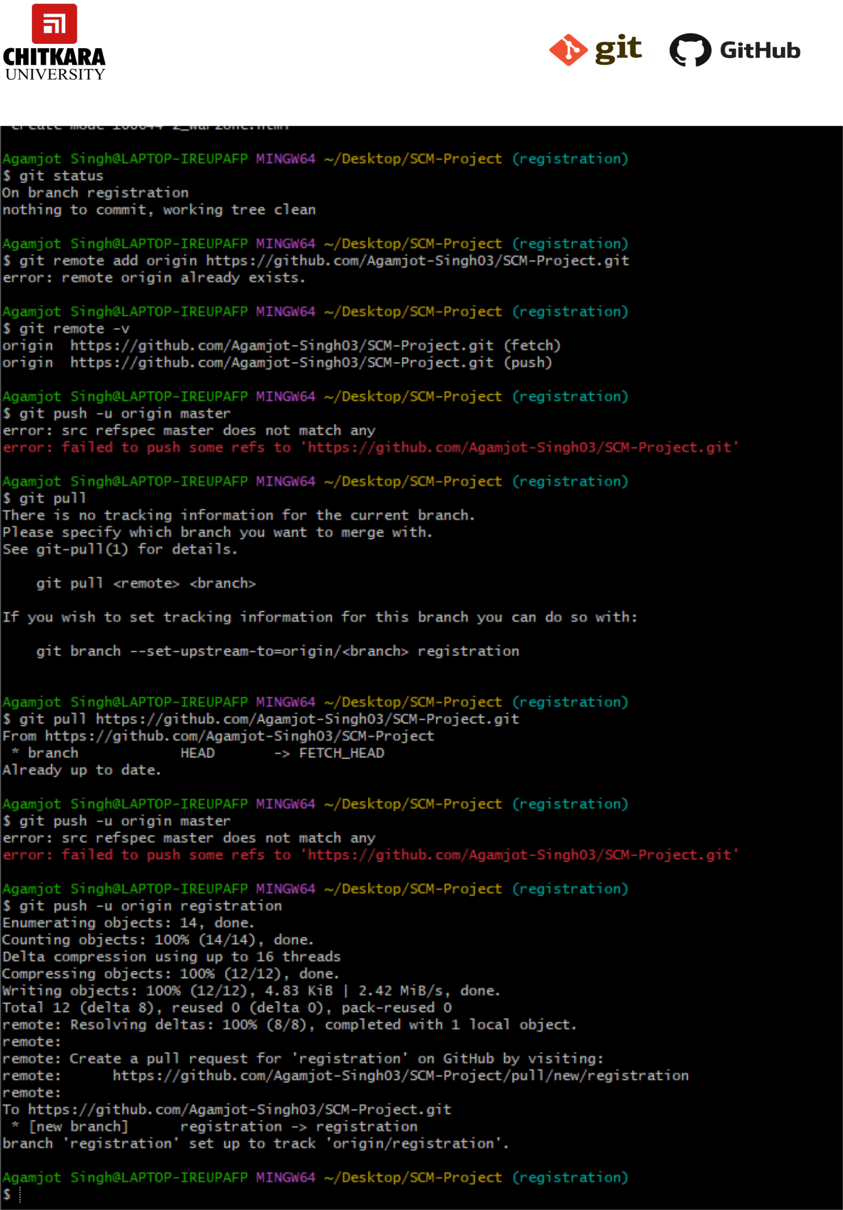

CS181 Page 29



**Events**

An event is a specifc activity in a repository that triggers a workfow run. For example, activity can originate from GitHub when someone creates a pull request, opens an issue, or pushes a commit to a repository. You can also trigger a workfow run on a schedule, by posting to a REST API, or manually.

For a complete list of events that can be used to trigger workfows, see Events that trigger workfows.

CS181 Page 30



**NETWORK GRAPHS**

The network graph is one of the useful features for developers on GitHub. It is used to display the branch history of the entire repository network, including branches of the root repository and branches of forks that contain commits unique to the network.

A repository's graphs give you information on traffic, projects that depend on the repository, contributors and commits to the repository, and a repository's forks and network. If you maintain a repository, you can use this data to get a better understanding of who's using your repository and why they're using it.

Some repository graphs are available only in public repositories with GitHub Free:

•

•

•

•

•

•

Pulse

Contributors

Traffic

Commits

Code frequency

Network

Steps to access network graphs of respective repository

1. On GitHub.com, navigate to the main page of the repository.

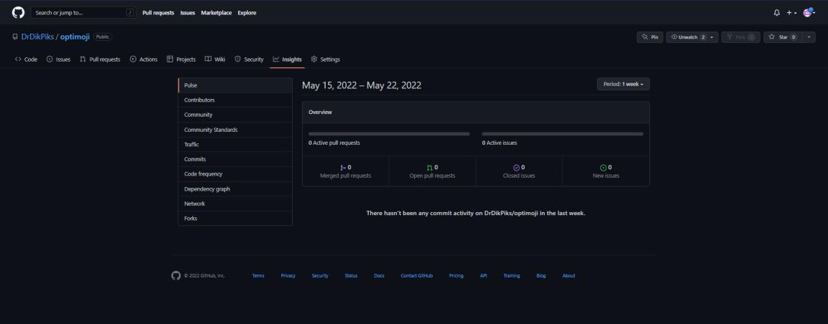

2.Under your repository name, click Insights.

CS181 Page 31

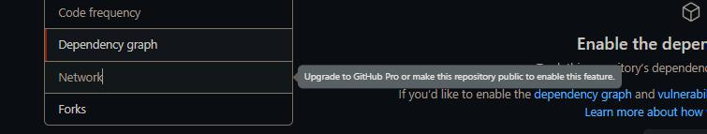

You will get the network graph of your repository which displays the branch history of the entire repository network, including branches of the root repository and branches of forks that contain commits unique to the network.

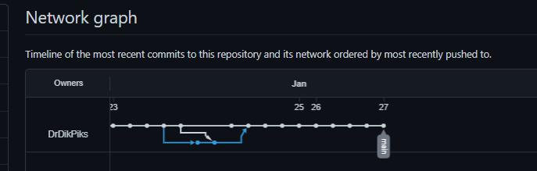

CS181 Page 32